**World Quant University**

**Professor: Ritabrata Bhattacharyya**

**Alpha Design II**

Nikolas Lippmann Pareschi - [nikolaslippmann@gmail.com](mailto:nikolaslippmann@gmail.com)

Introduction: Spyder PEP8 checker is truly a time saver, as I discovered reading the Piazza forum in Python 2. So, I have used it again for all classes and this Project I from Alpha Design II. I tried my best to avoid using modular code.

**Project: Optimizing Trend Trading using Mean Reversion Inputs**

* + - 1. Write a program that prompts the user to enter any valid stock symbol available in an appropriate financial website such as Google Finance, Yahoo Finance, Quandl, CityFALCON, or another similar source for NYSE & NASDAQ. Ensure proper error handling for wrong user inputs.

I have made it necessary for the stock chosen to be listed in nyse or Nasdaq:

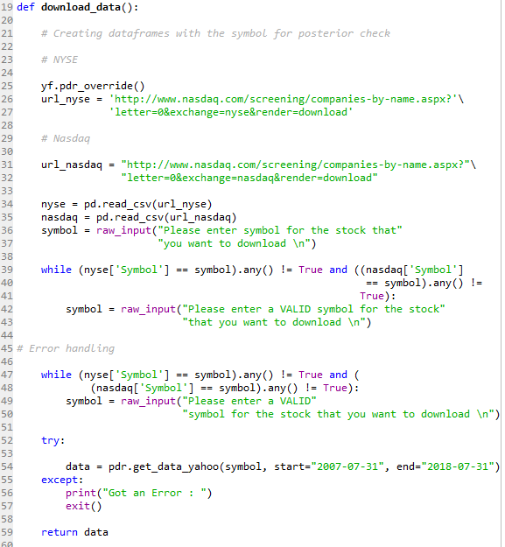

* + - 1. Download/access End-of-day and Hourly data for last 10 years for user entered ticker from an appropriate financial website such as Google Finance, Yahoo Finance, Quandl, CityFALCON, or another similar source.

I That was done in the code above. I demanded a history of 11 years so we could get the 2008 metldown.

* + - 1. Constitute a Simple Moving Average crossover system for trend trading on the daily time frame

I did this inside the main function:

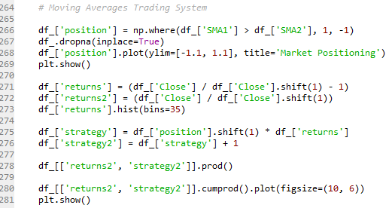

Some plots:

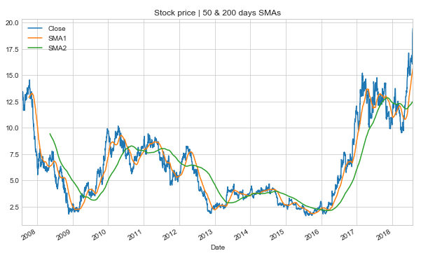

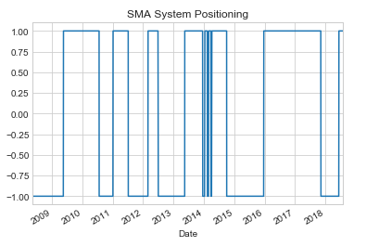

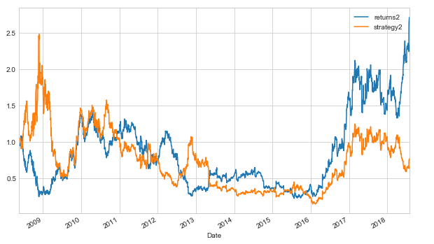

* + - 1. Calculate 2 period RSI (Relative Strength Indicator) values for the stock in question on the hourly time frame to identify overbought and oversold conditions

I computed the RSI in this function:

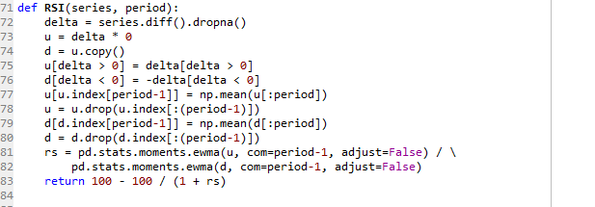

Plot:

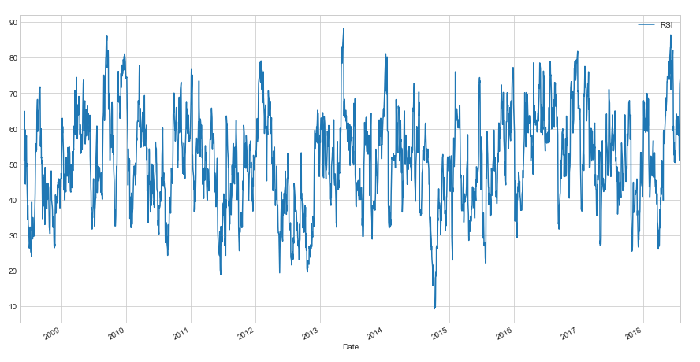

Nevertheless I was not able to download the hourly data. This happened because google has also changed, as yahoo its API. I tried this code among others:

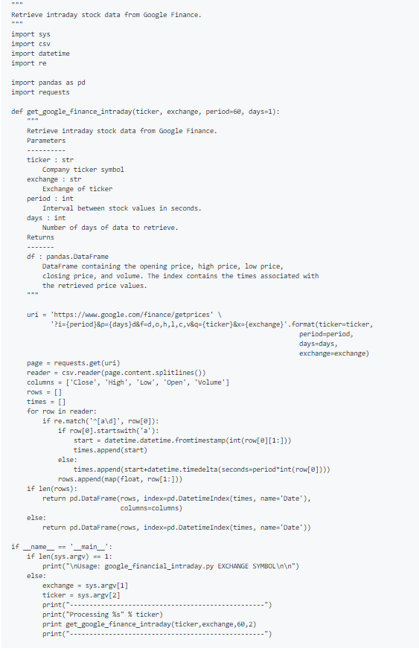

But faced the same problem that other users are posting in the forum:



Source: <https://gist.github.com/lebedov/f09030b865c4cb142af1>

* + - 1. Time your entries in the direction of the longer term trend (as identified by daily moving averages) by matching with  the most favorable relative strength condition on the smaller time scale (as identified by RSI calculated on hourly data). For example, enter long when shorter term moving average crosses over the longer term moving average AND the stock in oversold in the hourly time frame
      2. Exit trade on MA Crossover in opposite direction AND favorable RSI indications on smaller time scale
      3. Consider Equal amount invested for every trade

Actually I took a long time to figure out how to do this. I used ffill (aha moment) in the end. I tried using 2 for loops but faced difficulties. I would like to know how to do the same with the loops, other languages do not have ffill after all. In other words I was trying to code the ffill.

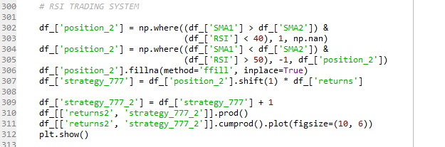

* + - 1. Clearly mention and explain all trading rules

This trading system is very interesting and the trader Cesar Alvarez has published several similar trading systems. The objective is to follow the longer trend and buy/sell and sell off / expansions in lower timeframes.

Some Plots:

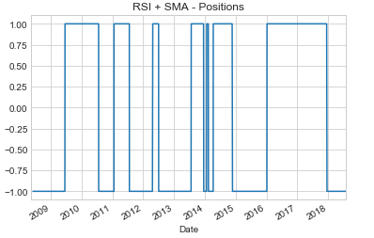

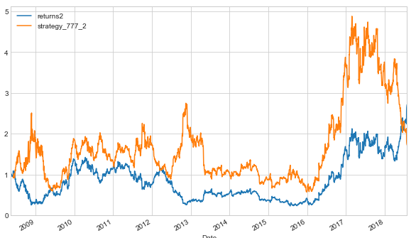

* + - 1. Estimate and compare historic performance for such a system with and without the RSI indicator usage for the period of data downloaded by calculating all the relevant KPIs as marked below

Win %

Win to Loss Ratio

Mean Return Per Trade

Maximum Consecutive Losers

Maximum Drawdown

CAGR

Lake Ratio

Gain to Pain Ratio

These are the KPIs calculated considering AMD stock:

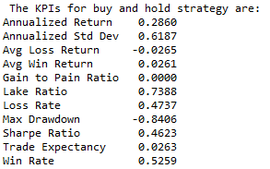

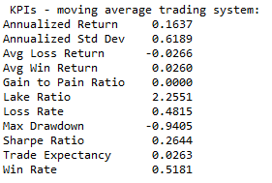

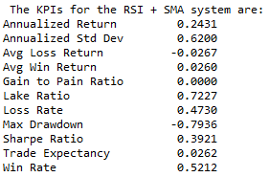

These KPIs were calculated using this class, which was provided by Professor Steven Stelk in Piazza in Risk Management classes:

